**Protective Effects of Ethyl Acetate Extract from *Ficus Carica L.* Leaves Against CCl4-Induced Hepatotoxicity In Vitro and In Vivo**

Syeda Hira1*, Tanveer Tara1, Muhammad Gulfraz2

1Department of Health Sciences Technology, National Skills University, Islamabad (44000), Pakistan.

2University Institute of Biochemistry and Biotechnology, Pir Mehr Ali Shah Arid Agriculture University, Rawalpindi (43490), Pakistan.

**Corresponding author*:** Dr. Syeda Hira ([syeda.hira@nsu.edu.pk](mailto:syeda.hira@nsu.edu.pk))

**ABSTRACT**

**Background:**Liver diseases lead to significant health complications such as fatty liver disease, hepatitis and liver failure. Medicinal Plants contain active compounds that significantly help in combating different kind of liver diseases including liver cirrhosis and treatment. The main purpose of present study was isolation and identification of hepatoprotective components present in *F.carica* leaves.

**Methods:**The study was designed for identification of compounds which are responsible for hepatoprotective activity of ethyl acetate fraction. Hepatoprotective effect was determined by *in vitro* and *in vivo* methods. HepG2 cell line was used to determine *in vitro* effect. Carbon tetrachloride was used to induce toxicity and silymarin drug was used as standard drug for comparison with plant fractions. Based on the results, to identify the bio active component analysis of most active sub-fraction was done by Liquid Chromatography-Mass Spectrometry and Fourier Transform–Infra Red spectroscopy. For *in vivo* study albino mice were used as model and toxication was induced by carbon tetrachloride. .Hepatoprotective activity was determined by estimating liver parameters such as alanine transaminase (ALT), alkaline phosphatase (ALP), aspartate aminotransferase (AST), bilirubin and total protein.

**Results:** Significant (P <0.05) hepatoprotective activity was exhibited by sub-fraction FVI of *F.carica* leaves, which was equivalent to the standard drug silymarin. It significantly (P <0.05) restored the level of liver biomarkers toward normal.

**Conclusion:** Our findings confirmed the ethyl acetate fraction of *F.carica have a significant hepatoprotective* effect. Sub-fraction of **FVI** could be promising candidate for development of hepatoprotective drug due to presence components in it. Further clinical investigations of this fraction are recommended.

**Keywords:** *Ficus carica,* Hepatoprotective, Carbon tetrachloride, Liver markers, Bioactive Compounds

**HOW TO CITE:** Hira S, Tara T, Gulfraz M. Protective Effects of Ethyl Acetate Extract from *Ficus Carica L.* Leaves Against CCl4-Induced Hepatotoxicity In Vitro and In Vivo. National Journal of Life and Health Sciences. 2024 Sept; 3(2), 87-93.

DOI: <https://doi.org/10.62746/njlhs.v3n2.50>

Date of Submission: 12/03/2023 Date of Revision: 01/06/2024 Date of Acceptance: 25/07/2024

**INTRODUCTION**

The most severe medical issue now days are the liver diseases, a large number of medicines are available for liver ailment treatments but due to their side effects counterpart for them is also required.1 About 2% of the body weight is comprises of liver and it is the vital organ. Liver helps in detoxification of drugs, xenobiotics, in fact metabolism of body is regulated by liver. Various chemicals are responsible for the toxicity of liver, among which carbon tetrachloride is also known.2 CCl4 which itself is a stable molecule; but the enzyme cytochrome p450 activated it into the free radical which in return cause the lipid peroxidation and damaged the hepatocytes.3,4 People relied on medicinal plants from century and from last few decades the utilization of medicinal plants is again in interest for researcher because there are some side effects of allopathic medicines as compared to traditional one.5 Nature has enriched the medicinal plants with bioactive compoundsincluded tannins, saponins, phenols and flavonoids.6 The therapeutic approach of medicinal plants is based on active components in them and many of compounds are reported earlier for effective treatment of liver diseases.7

*Ficus carica* is a medicinal plantof family Moraecea. Ficus genus is considered to be largest genera with about 750 known families. This genus seeks great importance due to high nutritive value and they have been used for centuries by humans.8 *F. carica* is a deciduous tree and shrub and believed to be first plant cultivated on earth. Its body parts such as fruit, stem, and leaves are all considered to be effective as well. Various phytochemicals present in *F.carica* have pharmacological role.9 Although leaves of *F. Carica* are not edible part but they are very effective and only few of the research work are reported on this part. The purpose to conduct this study to evaluate hepatoprotective activity of acetate fraction of Fig leaves which was further fractionated into sub-fractions via column chromatography. The main focus of the study was bioactivity guided isolation of active fraction which possessed hepato- protective components. Finally, *in vivo* hepatoprotective effect of most active fraction is determined in Swiss albino mice.

**METHODS**

**Plant material**

Collection of *F.carica* leaves were done from different sectors of Islamabad during the month of July 2020. Plant was identified by Dr. Rahmatullah Qureshi expert taxonomist from Department of Botany, PMAS-AAUR and submitted to the university herbarium with voucher specimen no 2459.

**Extraction and bioactivity guided fractionation of leaves of *F.carica***

Leaves of *Ficus carica* were ground into powder after shadow drying. Maceration process was used for preparation of extract; about 5 kg leaf powder was soaked into 95 % methanol. Shaked at room temperature for 3 days. After filtration solvent was absorbed by rotary evaporator (Heidolph 36001270, Germany) at 40oC. The crude methanolic extract (108 g) was added in distilled water and fractioned into separatory funnel by adding solvents of increasing polarity to get *n*.hexane (2 g ), chloroform (18 g), ethyl acetate (33 g) and aqueous fraction (52 g ) as shown in Fig. 1. Organic solvents were dried with rotary evaporator and aqueous fraction was lyophilized. Sample was stored at 4 oC for further use. After preparation of crude methanolic extract and its fraction they were assessed for *in vitro* hepatoprotective activity, ethyl acetate fraction was found as most active fraction.10 Fraction of ethyl acetate was run through column using silica gel and elution was done by using solvent mixture of different polarity such as *n*. hexane and methanol in the ratio of (1:0 to 0:1) and ethyl acetate and methanol in the ratio of (1:0 to 0:1). Similar fractions pooled into eight major sub-fractions (FI - FVIII) based on assessment from thin layer chromatography (TLC).

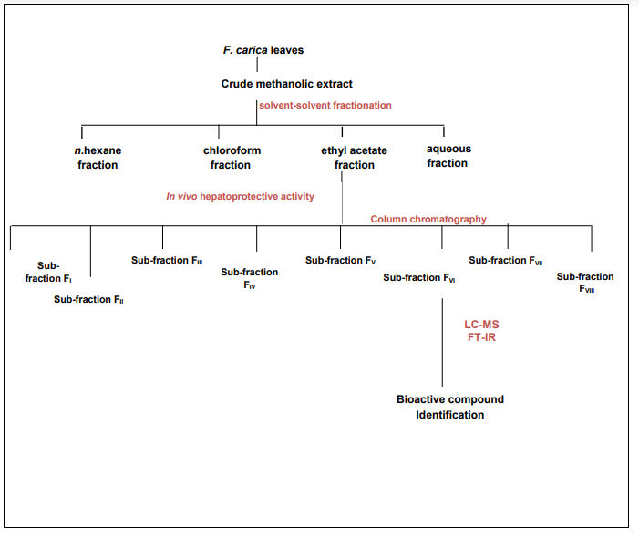

Figure 1: Experimental protocol for extraction and isolation of hepatoprotective compounds from leaves of *F.carica*

***In vitro* hepatoprotective activity**

After collecting fractions from the column (FI–FVIII), the hepatoprotective activity was assessed in vitro. This evaluation was performed using Human liver carcinoma HepG2 cell lines, provided by the Institute of Biomedical and Genetic Engineering at KRL Hospital in Islamabad. The cells were plated in a 96-well plate at a density of 10,000 cells per well and incubated for 24 hours in Dulbecco’s Modified Eagle Medium (DMEM), supple- mented with 10% fetal bovine serum (FBS) under a humidified atmosphere containing 5% CO₂ at 37°C. HepG2 cell toxicity was induced using 1% CCl₄. The cells were then treated with medium containing CCl₄ with or without fractions of *Ficus carica* at concentrations of 50 and 100 µg/ml. After 24 hours, cytotoxicity was assessed by measuring the percentage viability of HepG2 cells using the MTT assay.11 Biochemical markers (ALT, Bilirubin, AST, and ALP) were determined by using their respective diagnostic kits (AMS, Italy) and reduced glutathione (GSH) activities were determined by using kits from Cayman Chemical Company.12

**Bioactivity guided compounds profiling**

In this study, the fraction demonstrating the highest hepatoprotective activity was selected for further analysis using LC-MS and FT-IR to identify bioactive compounds.

**Liquid chromatography – Mass spectroscopy analysis (LC-MS)**

The most potent sub-fraction of *Ficus carica* was prepared in methanol for LC-MS analysis. The analysis was carried out using an Agilent Technologies LC-MS system (Agilent

6310 Ion Trap), equipped with an Agilent Zorbax Eclipse XD B-C18 column (2.1 x 150 mm, 3.5 μm). The Mass Hunter software version 05.00 was utilized for data acquisition and analysis of all parameters.

**Fourier Transform-Infrared (FT-IR) spectroscopy analysis**

FT-IR analysis of most active sub fraction of *F.carica* sample was carried out in FT-IR (Alpha II BRUKER, Germany) Spectrophotometer. About 5mg of Fraction VI was mixed potassium bromide (100 mg) and small disc of 3mm was prepared by compressing the sample. Between 500 and 3500 cm-1 absorption range was selected and disc was placed in sample holder to identify immediately. Functional groups obtained were matched with available data.

***In vivo* hepatoprotective activity of bioactive sub-fraction**

**Experimental animals**

Male Swiss albino mice, weighing between 25-30 g and aged six to eight weeks, were obtained from the National Veterinary Laboratories in Islamabad. After procurement, the mice were housed in environmentally controlled cages with free access to food and water. They were acclimatized for one week before the experiment, maintained at a normal room temperature, and kept on a 12:12 hour light-dark cycle. The study was conducted following the guidelines provided by the NIH in Islamabad, Pakistan, and received approval from the Ethical Committee of PMAS-AAUR, under reference number PMAS_AAUR/BCH/326.

The experimental design included six groups. Group I, serving as the normal group, was treated orally with normal saline. Group II, the vehicle control group, received olive oil. Group III was administered CCl₄ at a dose of 0.2 ml/kg. Group IV was treated with the standard drug silymarin (50 mg/kg) orally for 5 days, along with 0.2 ml/kg CCl₄ twice a week. Group V received ethyl acetate sub-fraction FVI of *Ficus carica* at 25 mg/kg orally for 5 days, in combination with 0.2 ml/kg CCl₄ twice a week. Finally, Group VI was administered 50 mg/kg of the same ethyl acetate sub-fraction FVI for 5 days, also in combination with 0.2 ml/kg CCl₄ twice a week.

After completion of experimental study animals of all groups were anesthetized by using chloroform and blood was collected directly by acupuncture. Liver biomarkers (ALT, AST, ALP, Bilirubin Serum and TP) were determined from Serum, which was separated from blood by centrifugation at 3000 rpm for 10 minutes. For histopathological studies liver was dissected out and preserved in 10% formalin.

**Histopathology**

Cassettes of preserved liver of all animals were prepared. For dehydration processing and fixation was done. Tissue blocks were prepared and they were cut with microtome with average size of 5 µm. Hematoxylin and Eosin staining was done. Prepared slides were observed under light microscopes and photomicrographs of tissue were captured by using digital camera.

**Data analysis**

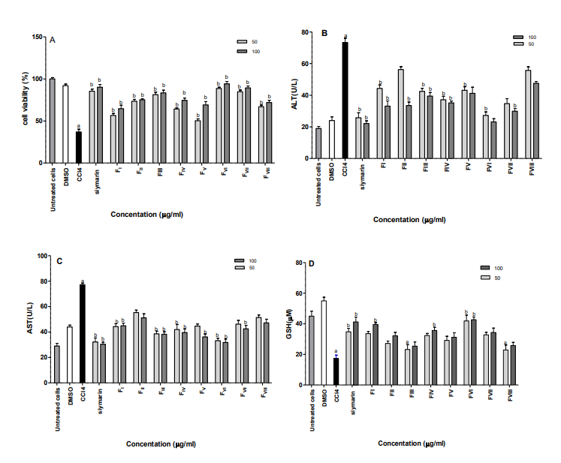The preliminaries were conducted in triplicate, and the results were expressed as mean ± standard deviation. ANOVA was used to assess the effects of various treatments. Statistical analysis was performed with GraphPad Prism 5.0 software. Multiple comparisons were conducted using Dunnett’s test, with a significance level set at P-value < 0.05.

**RESULTS**

**Bioactivity guided profiling of bioactive constituents**

After column chromatography total eight fractions were obtained (FI- FVIII) and their *in vitro* hepatoprotective activity was determined. As shown in Fig 2A, After 24 hours of exposure of HepG2 cells to CCl4. MTT assay was used to determine percentage viability. Different concentrations of *F.carica* fraction (50 and 100 µg/ml) were evaluated. CCl4 toxicity significantly (p < 0.05) decreased the cell viability (37.00 %) as compared to the untreated HepG2 cells (100 %). All fractions showed dose dependent increased in cell viability as shown in Fig. 2A. Sub-fraction FVI showed significant (p < 0.05) results (94.12 %), which was also higher than standard drug silymarin (90.12 %).

Liver biomarkers such as ALT and AST were assessed for all fractions (FI-FVIII) as shown in Fig.2B and 2C. CCl4 induced toxicity in HepG2 markedly increased (p < 0.05) the level of ALT, AST however treatment with ethyl acetate sub fractions decrease the raised value of liver Biomarkers.

As shown in Fig 2D treatment with CCl4 decrease the level of GSH. However treatment of HepG2 cells with *F.carica* fractions (FI-FVIII) reversed the toxicity of CCl4 by enhancing the activity of antioxidant enzyme GSH at both doses (50- 100 µg/ml).

Among all sub-fractions, the sub fraction **FVI** showed strong (p < 0.05) effect on enzyme levels (AST, ALT, GSH and SOD) which were equivalent to standard drug silymarin shown in Figure 2.

Figure 2: Hepatoprotective effect of ethyl acetate sub-fractions of *F.carica* on HepG2 cells.

1. Cell viability **B.** ALT **C.** AST **D.** GSH.

Results were expressed as mean ± S.D. b showed significant variation from CCl4 toxicated group at (P<0.05).a showed significant difference from normal group at (P < 0.05). *In vitro* hepatoprotective activity was significantly observed in sub-fraction **FVI** that is why it was selected LC- MS analysis to identify bioactive constituents present in it. Direct induction mode was used for identification of compounds. Identification of compounds was done by m/z ratio in which each fragment as shown in Figure 3. With help of fragmentation pattern six compounds were tentatively identified as Shown in Table 1.

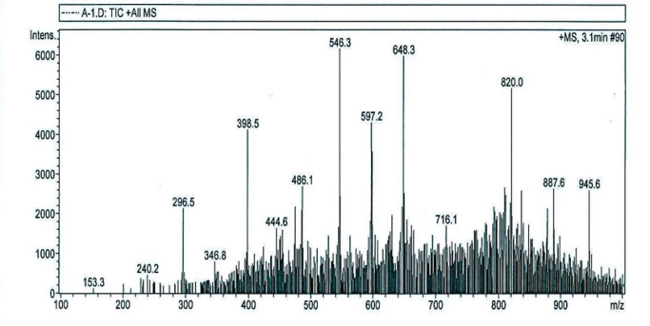

Figure 3:LC-Mass Spectrometry of Ethyl Acetate Sub-Fraction FVI Derived from *Ficus carica* Leaves

Table 1: LC-Mass Spectrometry Analysis of Ethyl Acetate Sub-Fraction FVI: Identification of Putative Compounds in Positive Ionization Mode

|  |  |  |  |
| --- | --- | --- | --- |
| **Peak** | **Observed m/z** | **Tentative identification** | **Molecular Formula** |
| **1** | 153.3 | Coumarin | C9H6O2 |
| **2** | 240.2 | Isobornyl acetate | C12H20O2 |
| **3** | 296.5 | Lupeol acetate | C30H50O |
| **4** | 546.3 | Unknown | _ |
| **5** | 597.2 | Quercetin-3-O-hexose O-pentoside | C15H10O7 |
| **6** | 648.3 | Unknown | _ |
| **7** | 716 | Unknown | _ |
| **8** | 820.0 | Ellagitannin | C48H30O30 |
| **9** | 887 | Unknown | _ |
| **10** | 945.6 | Gincenoside RB1 | C54H92O23 |

The functional groups present in bioactive compounds can be determined by FT-IR, which helps in identification of compounds. Fraction FVI, FT-IR analysis shows that it comprises aromatics, phenols, alkanes, aldehydes alkynes, alcohols, carboxylic acids, amines and methylene as shown in Table 2. Hydroxyl group at 3316.94 cm-1 of absorption showed phenols are present in it. Presence of fatty acid was indicated by absorption at 2928.59 cm-1 which represents C-H stretch of methylene, ester was shown at band 1713.20 cm-1, stretch of aromatic ring was observed at 1650.92 cm-1 and 1615.34 cm-1. Band at 1512.96 cm-1 showed another OH of phenol ring, CH3 presence indicated at absorption band 1363.75cm-1. The band at 1032.81cm-1 showed CO stretch of alcohol and while at 1230.98 cm-1 showed C-N stretch of amine group shown in Fig. 4. However, figure 5 shows the structure of putative compounds.

***In vivo* hepatoprotective activity of most active sub-fraction FVI**

The animals in the toxic-group treated with CCl₄ exhibited a notable (P < 0.05) increase in liver biomarkers, including ALP, AST, ALT, and bilirubin levels, along with a decrease in total protein, indicating liver damage, as shown in Table 3. However, administration of sub-fraction FVI at a higher dose of 50 mg/kg significantly (P < 0.05) restored the elevated liver biomarkers and protected hepatocytes from CCl₄-induced toxicity, leading to an increase in total protein levels.

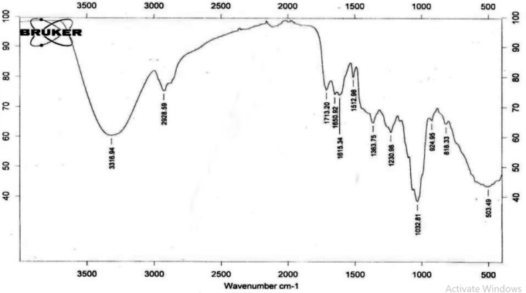

Figure 4: FT-Infrared spectrum of sub-fraction FVI of ethyl acetate fraction of *F.carica* leaves

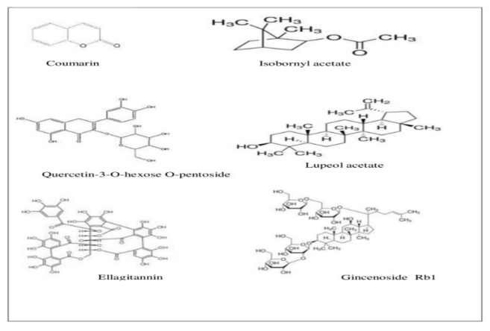

Figure 5: Structure of putatively identified compounds from fraction FVI .

**Histopathology findings**

Histopathology of liver sections which were treated with normal saline and olive oil showed normal cell structure with properly stained nucleus having normal sinusoidal spaces surroundings. Complete loss of cellular architecture was shown in histopathology of CCl4 treated group shown in Fig. 6 C. CCl4 toxicities in hepatocytes result from the accumulation of fats and infiltration showed necrosis. Central vein expanded which led to congestion of sinusoidal spaces. However, treatment with plant sub-fraction shows both doses 25 and 50 mg/kg reduces the effect of CCl4 Figure 6E and F.

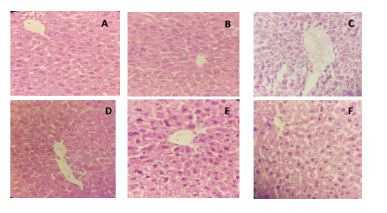

Figure 6: Histopathology of mice liver sections. A.Normal control B. Olive oil treated C. CCl4 toxic control D. Silymarin (standard drug) E. Sub- fraction FVI of *F.carica* 25 mg/kg F. Sub- fraction FVI of *F.carica* 50 mg/kg

Table 2. FT-Infrared Peak Values and Associated Functional Groups in the FVI Sub-Fraction of the Ethyl Acetate Extract of *Ficus carica* Leaves

|  |  |  |  |
| --- | --- | --- | --- |
| **Sr. No.** | **Frequency Range (cm⁻¹)** | **Observed Frequency (cm⁻¹)** | **Functional Group** |
| **1** | 3400-3200 | 3316.94 | O-H stretch indicating hydroxyl group with hydrogen bonding |
| **2** | 2800-3000 | 2928.59 | Symmetric C-H stretch |
| **3** | 1670-1780 | 1713.20 | C=O carbonyl stretch associated with ester group |
| **4** | 1590-911 | 1032.81 | C-O stretch characteristic of alcohol |
| **5** | 1458-1591 | 1512.96 | Phenolic O-H bending mode |
| **6** | 1450-1660 | 1650.92 | C-C stretch in an aromatic ring |
| **7** | 1432-1621 | 1615.34 | Aromatic ring C-C stretch |
| **8** | 1367-1315 | 1363.75 | Methyl (CH₃) bending mode |
| **9** | 1030-1230 | 1230.98 | C-N stretch of an amine group |

Table 3: Hepatoprotective effect of *Ficus carica L*. ethyl acetate sub-fraction on serum biochemical parameters

|  |  |  |  |  |  |
| --- | --- | --- | --- | --- | --- |
| **Groups** | **AST (IU/L)** | **ALP (IU/L)** | **ALT (IU/L)** | **Bilirubin (g/dL)** | **TP (g/dL)** |
| **I** | 45.7 ± 1.89 | 48.9± 1.13 | 33 ± 2.34 | 0.40± 2.12 | 7.23 ±1.56 |
| **II** | 51.3± 2.78 | 52.7± 2.56 | 38.1 ± 2.35 | 0.43± 1.34 | 6.21±2.29 |
| **III** | 195 ±1.11**##** | 317± 2.56## | 165± 1.18**##** | 2.91 ±1.90## | 2.23±1.67## |
| **IV** | 46.3 ± 2.19** | 64.9 ± 1.67** | 35.8± 1.78** | 0.35 ±2.17** | 6.67±2.69** |
| **V** | 61.9± 3.24 | 71.2 ± 1.81 | 55.3± 1.34** | 0.68 ±1.67 | 6.78±1.45 |
| **VI** | 51.3±1.78** | 63.0 ±3.14** | 42.1 ± 0.81** | 0.31± 1.19** | 7.00±3.23** |

Mean ± SD were used for presentation of cumulative data of five mice per group. Differences from the CCl₄-treated group are marked by ** (P < 0.05), while ## denotes significant differences from the normal group (P < 0.05).

**DISCUSSION**

In the present study with the help of column chromatography ethyl acetate was further fractionated. After running column eight sub-fractions (FI-FVIII) were obtained. *In vitro* hepatoprotective effect of each fraction was monitored. CCl4 was used to induce toxicity in HepG2 cell lines. CCl4 intoxication resulted in generation of reactive oxygen species which usually resulted in lipid peroxidation. Lipid peroxidation reached its maximum after 24 hours of exposure to CCl4.13

CCl4 exposure caused leakage of liver enzymes ALT and AST which indicated cellular damage.14 Treatment with ethyl acetate fractions of *F.carica* reversed enzymes toward normal level, which suggested its curative effect that might be due to presence of bioactive constituents that reversed the toxic effect of CCl4. Oxidative stress generated due to CCl4 decreased level of GSH and SOD which are antioxidant enzymes in cells whereas treatment with ethyl acetate fractions of *F.carica* at different concentration enhanced the activity of enzymes that might be due to presence of antioxidant compounds in *F.carica*.

The therapeutic activity of medicinal plants is due to presence of phytochemicals in them.15 In present study sub-fraction **FVI** exhibited significant *in vitro* hepato- protective activity, so the active components existing in it were recognized by LC-MS and FT-IR. Table 1 shows the compounds present fraction VI, compounds like Lupeol acetate and Coumarins has been previously reported.16,17 Coumarins are also effective against the toxicity of CCl418. Numerous studies indicated that the protective effect of Coumarin is due to its molecular structure. The hydroxyl groups present on benzene ring attributed to its detoxification function, they scavenged the free radicals generated after CCl4 induction.19-21 Antifungal and antibacterial activity of Isobornyl acetate is also reported.22 Hepatoprotective effect of Lupeol acetate has been reported earlier.23It also exhibited anti-cancer potential.24 Liver injury is caused due to excessive generation of reactive oxygen species, so being an antioxidant compound Lupeol acetate has ability to scavenge free radicals by donating hydrogen to them as a result free radicals get reduced and toxic effect of CCl4 on hepatocytes reversed Ellagitanin showed excellent antioxidant and hepato- protective activity as reported earlier.25 It possess both hexahydroxydiphenoyl and galloyl groups which protect liver from carbon tetrachloride induced damage and prevented leakage of ALT, AST and ALP in blood circulation.26 Ginsenoside RB1 also exhibited hepato- protective potential reported.27 It protects liver injury by inhibiting activity and expression of cytochrome P450 enzyme, which produces reactive oxygen species and cause lipid peroxidation.28 This study attributed the hepato- protective effect of *F. carica* ethyl acetate fraction because the identified compounds are already reported for their antioxidant and hepatoprotective activity. FT-IR analysis indicated presence of hydroxyl group, phenol group, aromatic ring which confirmed the presence of phenol and flavonoids and identified functional groups are present in compounds isolated in sub-fraction **FVI** shown in Fig. 5. These bioactive compound scavenged free radicals by donation of hydrogen and neutralized their oxidative effect.29

Animal study of most active sub fraction (**FVI**) was done. Carbon tetrachloride is used as a toxic for induction of minor hepatic injury in animals.30 The enzyme Cytochrome p450convert the stable molecule CCl4 into reactive free radical specie known as trichloromethyl (**.**CCl3)” and which further converted into “trichloromethyl peroxyl radical (CCl3OO...)” Formation of these free radicals depleted biomolecule and cause lipid peroxidation .31 Oxidative stress can lead to liver necrosis, cirrhosis, and atrophy. Enzymes such as ALP, AST, ALT, and total bilirubin are key indicators of liver condition. Elevated levels of these biomarkers in the blood suggest their leakage from hepatocytes into the bloodstream.32 In this study, administration of the ethyl acetate sub-fraction FVI from Ficus carica effectively reduced the elevated levels of these liver biomarkers at both doses (25 and 50 mg/kg), demonstrating the fraction’s therapeutic potential.

Liver is responsible for making many plasma proteins; the level of these plasmatic proteins reduces in case of liver diseases. The present study indicated the decrease in protein level by CCl4 administration as compared to the normal group animals. CCl4 decreases the level of these proteins by producing free radicals and disrupted the integrity of liver and imbalance its function. The level of proteins are decreased due to dissociation of ribosomes which are responsible for protein synthesis.32 Administration of fraction FVI at both concentrations 25 mg/kg and 50 mg/kg increased level of total protein, which indicated the presence of hepatoprotective compounds.

**CONCLUSIONS**

On the basis of data obtained from present study, it is concluded that *Ficus carica* leaves have strong hepatoprotective potential proved by *in vitro* and *in vivo* studies. Ethyl acetate fraction obtained from *F.carica* leaves is ideal candidate for production of natural hepatoprotective medicines.

**ACKNOWLEDGEMENT**

I would like to thanks to Department of Health Sciences Technology, National Skills University Islamabad and University Institute of Biochemistry and Biotechnology, PMAS Arid Agriculture University, Rawalpindi for providing facilities for research work and National Veterinary Laboratories, Islamabad, Pakistan for support in animal study.

**SOURCE OF FUNDING**

Not Applicable

**REFERENCES**

1. Abeer H, Hibah MA, Jihan MB, Amany KI, Seham EA. Evaluation of hepatoprotective activity of Adansonia digitata extract on acetaminophein- induced hepatotoxicity in rats. Evi. Bas. Compl. Alt. Med. 2016; 16:1­-7.
2. Al-Sayed E, Abdel-Daim MM. Protective role of Cupressuflavone from Cupressus macrocarpa against carbon tetrachloride-induced hepato- and nephro toxicity in mice. Planta Med. 2014; 80: 1665 -1671.
3. Meharie BG, Amare GG, Belayneh YM. Evaluation of Hepatoprotective activity of the crude extract and solvent fractions of Clutia abyssinica (Euphorbiaceae) leaf against CCl4-induced hepatotoxicity in mice.  J. Exp. Pharmacol. 2020;12: 137-150.
4. Ullah R, Al-said MS, Shahat AA, Naser A, Al-Mishari AA, Adnan M, Tariq A. Antioxidant and hepatoprotective effects of methanolic extracts of Zilla spinosa and Hammada elegans against carbon tetrachloride induced hepatotoxicity in rats. Open Chemistry.2018; 16: 133-140.
5. Ahn M, Kim J, Bang H, Moon J, Kim GO. Hepatoprotective effects of allyl isothiocyanate against carbon tetrachloride-induced hepatotoxicity in rat. Chem. Biol. Interact.2016; 254:102 -108.
6. Bourhia M, Laasri FE, Aghmih K, Ullah R, Alqahtani AS, Mahmood HM. Phytochemical composition, antioxidant activity, antiproliferative effect and acute toxicity study of Bryonia dioica roots used in North African alternative medicine. Intl.J.AgricBiol.2020; 23; 597-602.
7. Mousavi L, Salle RM, Murugaiyah V. **Phytochemical and bioactive compounds identification of Ocimum tenuiflorum leaves of methanol extract and its fraction with an anti-diabetic potential.** Int. J. Food Prop. 2018; 21:2390-2399.
8. Li Q, Tu Y, Zhu C, Luo W, Haung W, Liu W, Li Y. Cholinesterase, β-amyloid aggregation inhibitory and antioxidant capacities of Chinese medicinal plants. Ind. Crops. Prod. 2017; 108:512-519.
9. Irudayaraj SS, Christudas S, Antony S, Duraipandiyan V, Naif Abdullah AD, Ignacimuthu S. Protective effects of Ficus carica leaves on glucose and lipids levels, carbohydrate metabolism enzymes and β-cells in type 2 diabetic rats. Pharmaceut. Biol. 2017; 55 : 1074- 1081.
10. Fouad D, Al-Obaidi E, Badr A, Ataya FS, Abdel-Gaber R. Modulatory effect of Ficus carica on oxidative stress and hematological changes induced by gamma-radiation in male albino rats. Biologia. 2020; 75: 1313–1324.
11. Hira S, Gulfraz M, Naqvi SS, Qureshi RU, Gul H. Protective effect of leaf extract of Ficus carica L. against carbon tetrachloride-induced hepatic toxicity in mice and HepG2 cell line. Trop. J. Pharm. Res. 2021;  20:113-119.
12. Palabiyik SS, Karakus  E, Halici  Z, Cadirci  E, Bayir Y, Ayaz  G, Cinar I. The protective effects of carvacrol and thymol against paracetamol‑induced toxicity on human hepatocellular carcinoma cell lines (HepG2). Hum. Exp. Toxicol. 2016; 35: 1252‑1263.
13. Gonzalez LT, Minsky NW, Espinosa LE, Aranda RS, Meseguer JP, Perez PC. In vitro assessment of hepatoprotective agents against damage induced by acetaminophen and CCl4. BMC Complement. Altern. Med. 2017; 17: 39.
14. Krithika R, Mohankumar R, Verma RJ, Shrivastav PS, Mohamad IL, Gunasekaran P, Narasimhan S. Isolation, characterization and antioxidative effect of phyllanthin against CCl4-induced toxicity in HepG2 cell line. Chem. Biol. Interact.2009; 181: 351-8.
15. Saeed MA, Sabir AW. Irritant potential of triterpenoids from Ficus carica leaves. Fitoterapia. 2002; 73:417-420.
16. Oliveira AP, Valentao PJ, Pereira A, Silva BM, Tavares F, Andrade PB. Ficus carica L.: metabolic and biological screening. Food Chem. Toxicol.2009; 47: 2841-2846.
17. Atmaca M, Bilgin HM, Obay BD, Diken H, Kelle M, Kale E. The hepatoprotective effect of coumarin and coumarin derivates on carbon tetrachloride-induced hepatic injury by antioxidative activities in rats. J. Physiol. Biochem. 2011; 67:569-576.
18. Hoult JRS, Paya M. Pharmacological and biochemical actions of simple coumarins: natural products with therapeutical potential. Gen. Pharmacol. 1996; 27: 713-722.
19. 20.Okamoto T, Yoshida S, Kobayashi T, Okabe S. Inhibition of concanavalin A-induced mice hepatitis by coumarin derivates. Jpn J. Pharmacol.2001; 85:95-97.
20. 21. Wua CR, Huang MY, Lin YT, Ju HY, Ching H. Antioxidant properties of cortex Fraxini and its simple coumarins. Food Chem.2007; 104:1464-1471.
21. Tabanca N, Demirci F, Demirci B, Wedge DE, Baser KH. Composition, enantiomeric distribution, and antimicrobial activity of Tanacetum argenteum subsp. flabellifolium essential oil. J. Pharmaceut. Biomed. 2007; 45: 714-719
22. Mariana Z, Perez-Gonzalez A, Georgina S, Patricia DN, Simon HO, Martha L, Maria A. Hepato- protective and anti-Inflammatory activities of the Cnidoscolus chayamansa (Mc Vaugh) leaf extract in chronic model. Evi. Bas. Compl. Alt. Med. 2018; 18: 1- 12.
23. Liu K, Zhang X, Xie L, Deng M, Chen H, Song J, Long J, Li X, Luo J. Lupeol and its derivatives as anticancer and anti-inflammatory agents: Molecular mechanisms and therapeutic efficacy. Pharmacol Res. 2021; 164.
24. Al-Sayed E, Korinek M, Esmat A. Anti-inflammatory, hepatoprotective and antioxidant activity of ellagitannin isolated from Melaleuca styphelioides. Phytochemistry.2020; 177: 112-119.
25. Shimoda, Tanaka J, Kikuchi M, Fukuda  T, Ito  H, Hatano T, Yoshida T. Walnut polyphenols prevent liver damage induced by carbon tetrachloride and d-galactosamine: hepatoprotective hydrolyzable tannins in the kernel pellicles of walnut. J. Agric. Food Chem. 2008; 56: 4444-4449.
26. Lee HU, Bae EA, Han MJ, Kim NJ, Kim D.H. Hepatoprotective effect of ginsenoside Rb1 and compound K on tert-butyl hydroperoxide-induced liver injury. Liver Intoxicity 2005; 25: 1069-1073.
27. Kim HJ, Chun YJ, Park JD, Kim SI, Roh JK, Jeong TC. Protection of rat liver microsomes against carbon tetrachloride-induced lipid peroxi- dation by red ginseng saponin through cytochrome P450 inhibition. Planta Med. 1997;63: 415-418.
28. Shahat AA, Ullah R, Alqahtani AS, Alsaid MS, Husseiny HA, Al Meanazel O. Hepatoprotective effect of Eriobotrya japonica leaf extract and its various fractions against carbon tetra chloride induced hepatotoxicity in rats. Evi. Bas. Compl. Alt. Med. 2018;1: 1-8.
29. Lee YS, Cho IJ, Kim JW, Lee MK, Ku SK, Choi JS, Lee HJ. Hepatoprotective effects of blue honeysuckle on CCl4-induced acute liver damaged mice. Food Sci. Nut. 2019;7: 322-338.
30. Boshy ME, Abdelhamid F, Richab E, Ashshia A, Gaitha M. Attenuation of CCl4 induced oxidative stress, immunosuppressive, hepatorenal damage by fucoidan in rats. J. Clin. Toxicol. 2017; 7: 348-349
31. Kuzu N, Metin K, Dagli AF, Akdemir F, Orhan C, Yalniz M, Ozercan IH, Sahin K, Bahcecioglu IH. Protective role of genistein in acute liver damage induced by carbon tetrachloride. Mediators Inflamm. 2007; 1-6.
32. Kumar SS, Kumar BR, Mohan GK. Hepatoprotective effect of Trichosanthes cucumerin L. on carbon tetrachloride induced liver damage in rats. J. Ethnopharmacol. 2009; 123: 347-350.